**Program for infinite loop**

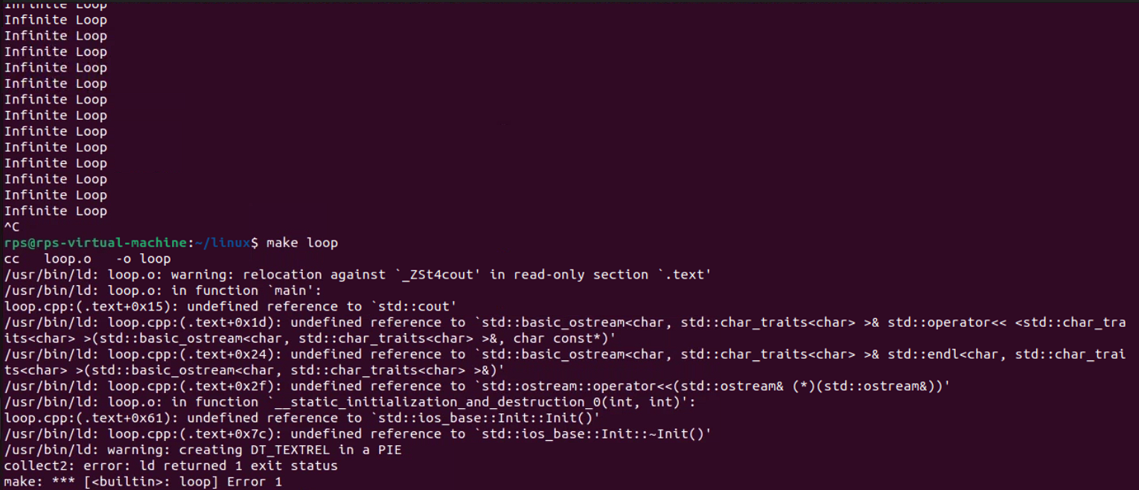

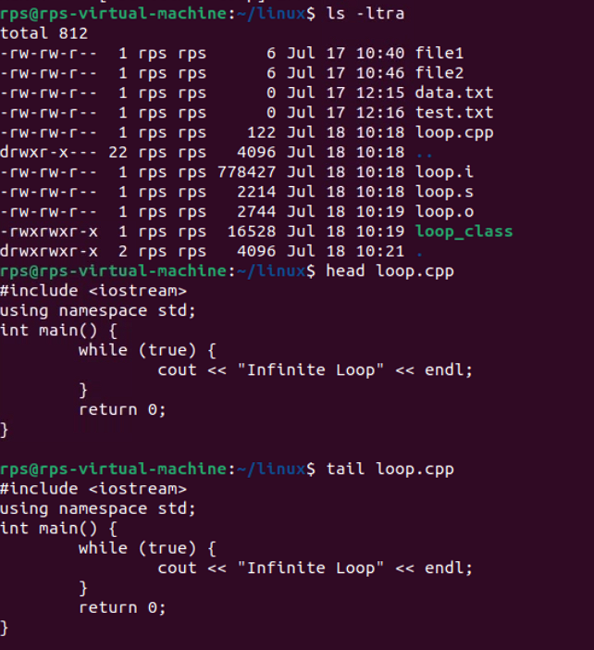

**ps-**show process status

**top-**show system usage statistics

**kill-**stop a program.the program is specified by process ID

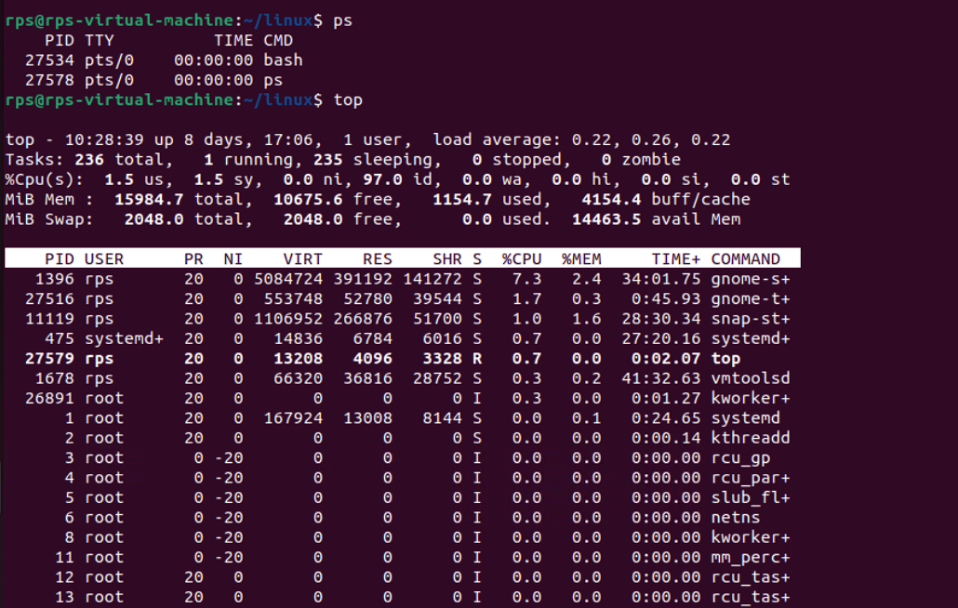

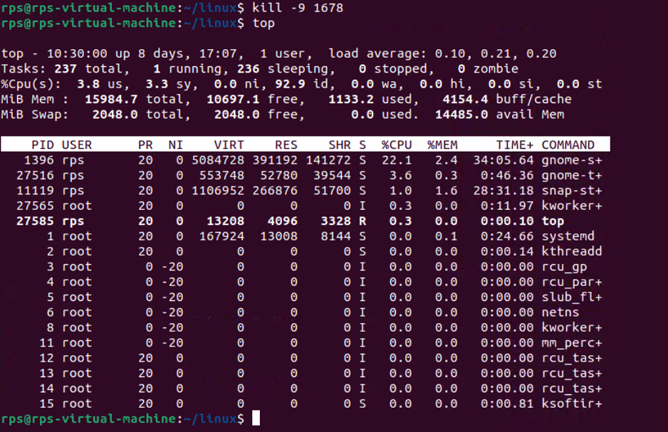

**Program for hello world:**

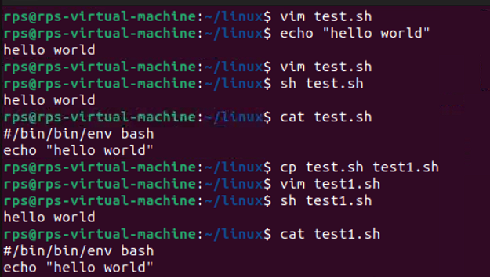

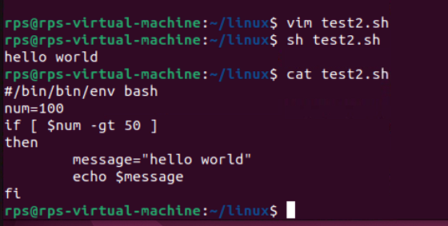

**Using if-else:**

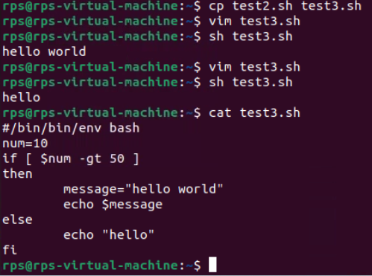

**Using for-loop:**

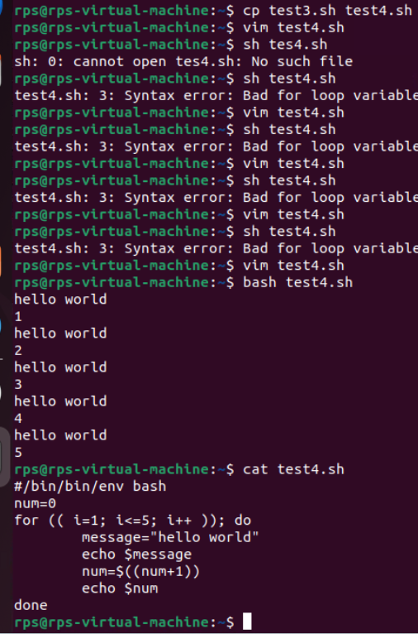

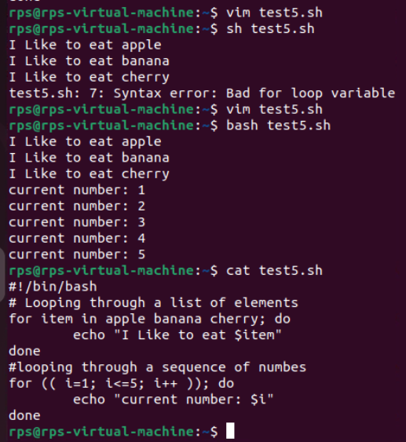

**Bash Scripting: Exercise**

**Exercise 1: Write a shell script called num_loop.sh that loops through every number 1 through 20 and prints each number to standard output. The script should also conditionally print I'm big! for every number larger than 10.**

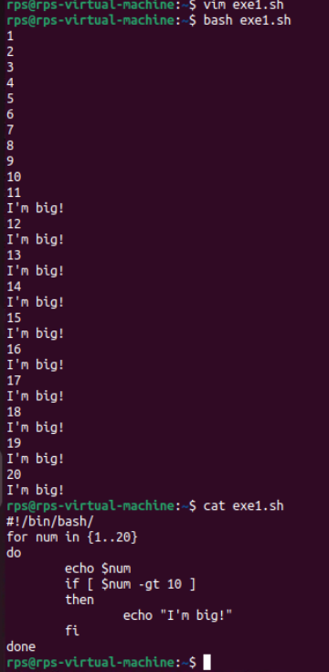

**Exercise 2: Write a shell script called my_folder. sh that takes in two arguments: your name (e.g. ayelet) and your name with the .txt ending (e.g. ayelet.txt). The script should call a function that creates a folder by the name of the first argument (e.g. ayelet) and then create a file inside by the name of the second argument(e.g.ayelet.txt).**

**For my name, my function would create a folder named ayelet and a file. named ayelet.txt inside of ayelet.**

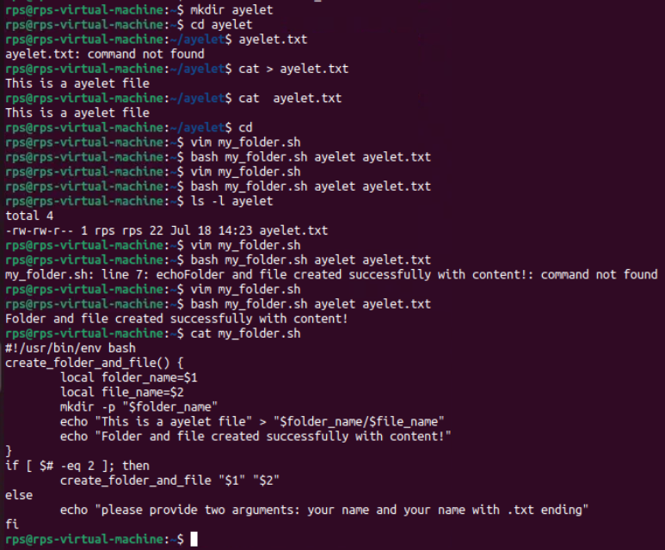

**File Search:**

**Write a command to find all files with the extension .txt in the /home directory and its subdirectories.**

find /home -type f -name "*.txt"

* find: The command used to search for files and directories.
* /home: The directory where the search begins.
* -type f: This option tells find to look for files only (not directories).
* -name "*.txt": This option specifies the pattern to match for file names, in this case, files ending with .txt.

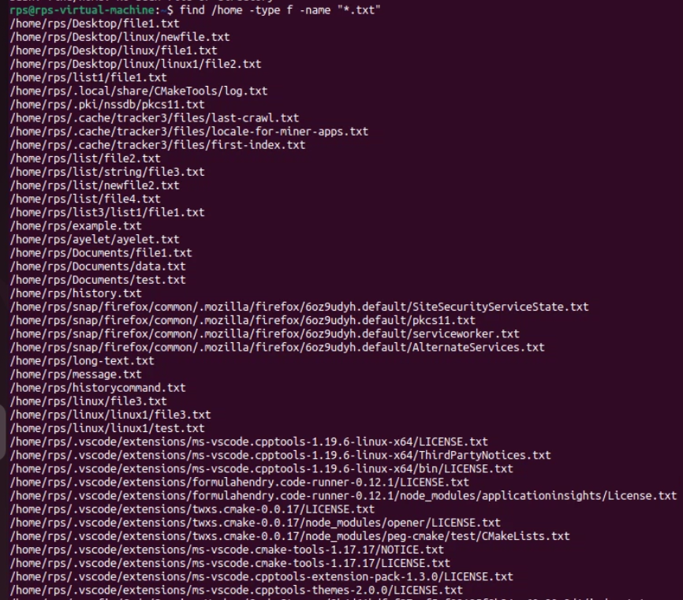

**File Permissions:**

**Write a command to change the permissions of all files in the /var/log directory to 644.**

find /var/log -type f -exec chmod 644 {} \;

* find: The command used to search for files and directories.
* /var/log: The directory where the search begins.
* -type f: This option tells find to look for files only (not directories).
* -exec: This option allows you to execute a command on each file found by find.
* chmod 644 {}: The command to change the file permissions to 644, where {} is a placeholder for each file found.
* \;: This indicates the end of the -exec command.

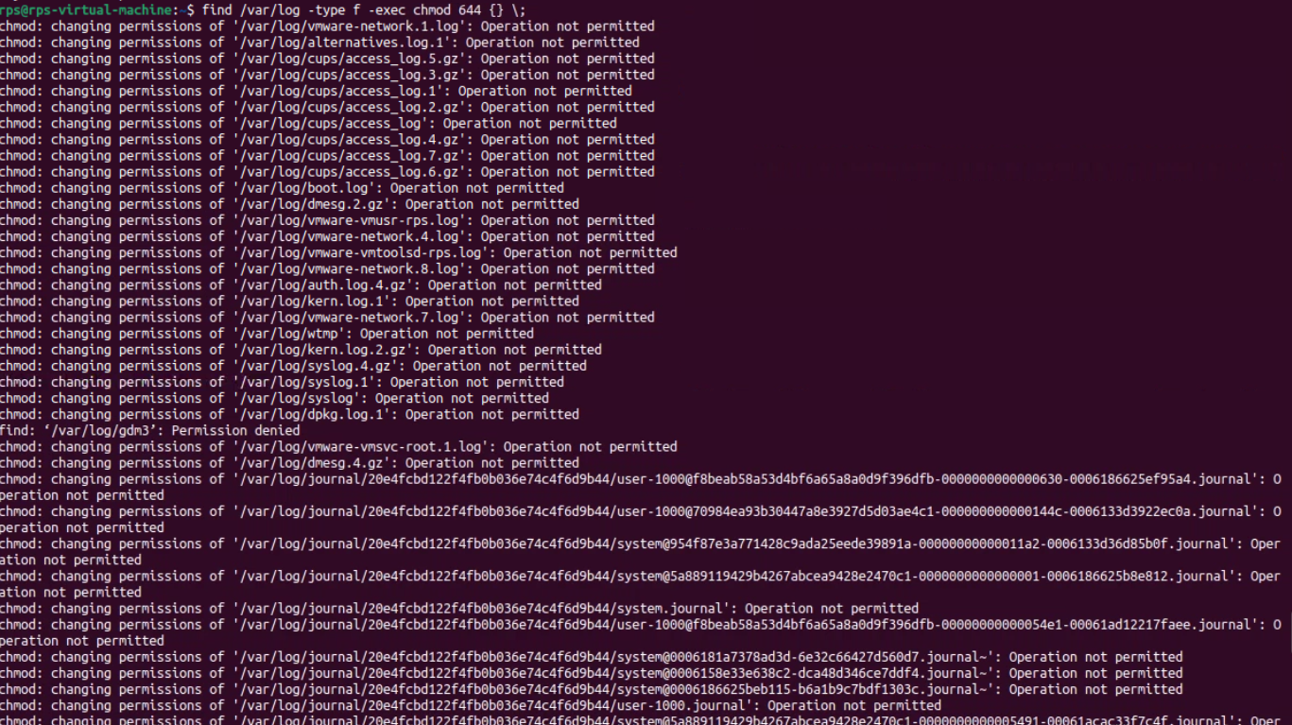**Disk Usage:**

**Write a command to display the disk usage of all directories in the /home directory in a human-readable format.**

du -h --max-depth=1 /home

* du: The disk usage command.
* -h: The human-readable option, which displays sizes in a readable format (e.g., K, M, G for kilobytes, megabytes, gigabytes).
* --max-depth=1: This limits the depth of directory traversal to 1, so it only shows the sizes of the directories directly under /home.
* /home: The directory for which you want to display disk usage.

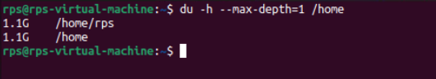

**Process Management:**

**Write a command to list all running processes that contain the name "apache" in their command line.**

ps -ef | grep apache

* ps stands for "process status".
* e stands for "all" and shows all running processes.
* f stands for "full" and shows the full command line.
* grep apache searches for the pattern "apache" in the output of the ps command.

**Text Processing:**

**Write a command to count the number of lines in a file named error.log.**

wc -l error.log

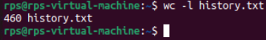

**Network Configuration:**

**Write a command to display the IP address of all network interfaces on the system.**

ip addr show

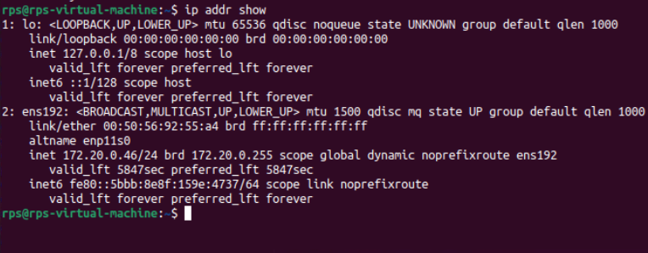**Package Management:**

**Write a command to install a package named htop using the package manager.**

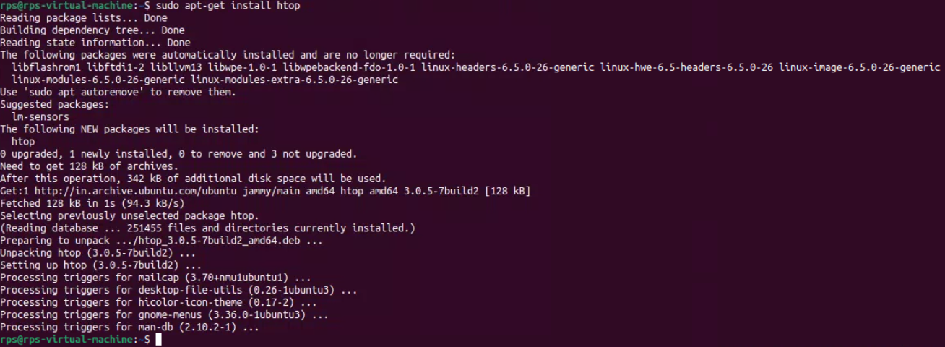

**User Management:**

**Write a command to add a new user named developer to the system.**

sudo useradd developer



**File Compression:**

**Write a command to compress a directory named backup into a .tar.gz file.**

tar -czvf backup backup.tar.gz backup/

**System Monitoring:**

**Write a command to display real-time system resource usage, including CPU, memory, and disk I/O.**

htop

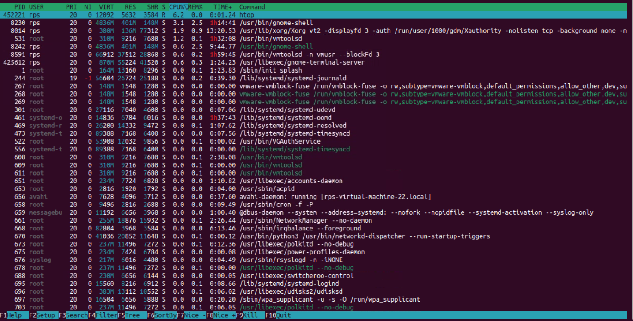

**Shell Scripts**

**Backup Script:**

**Write a shell script to back up a directory named /data to /backup with the current date appended to the backup file name.**

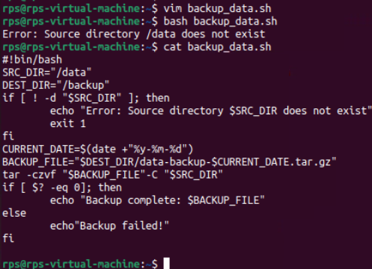

**Log Rotation:**

**Write a shell script to rotate log files in the /var/log directory, keeping only the last 7 days of logs.**

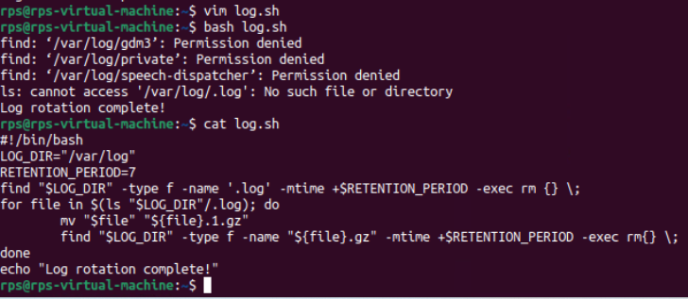

**User Report:**

**Write a shell script to generate a report of all users currently logged into the system and save it to a file named user_report.txt.**

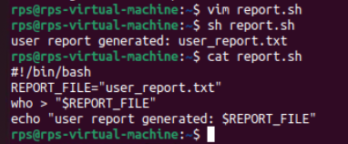

**Disk Space Alert:**

**Write a shell script to check the disk usage of the /home directory and send an email alert if the usage exceeds 80%.**

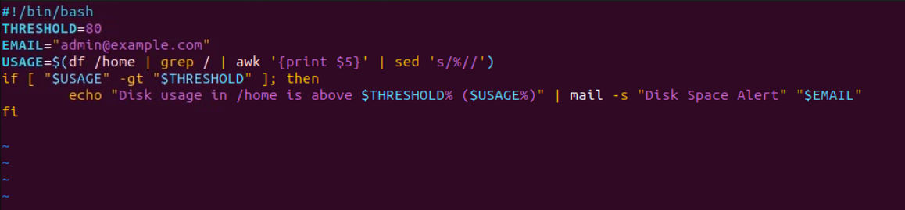

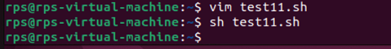

**Service Monitor:**

**Write a shell script to check if the nginx service is running and restart it if it is not.**

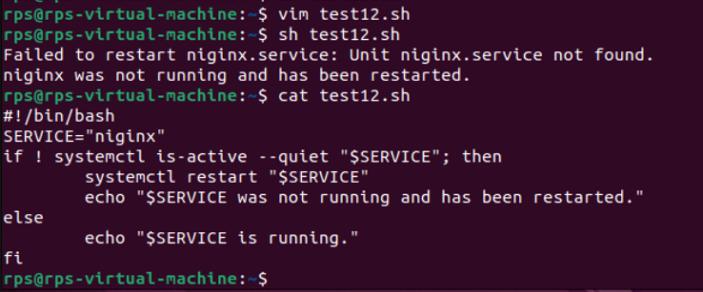

**File Cleanup:**

**Write a shell script to delete all files older than 30 days in the /tmp directory.**

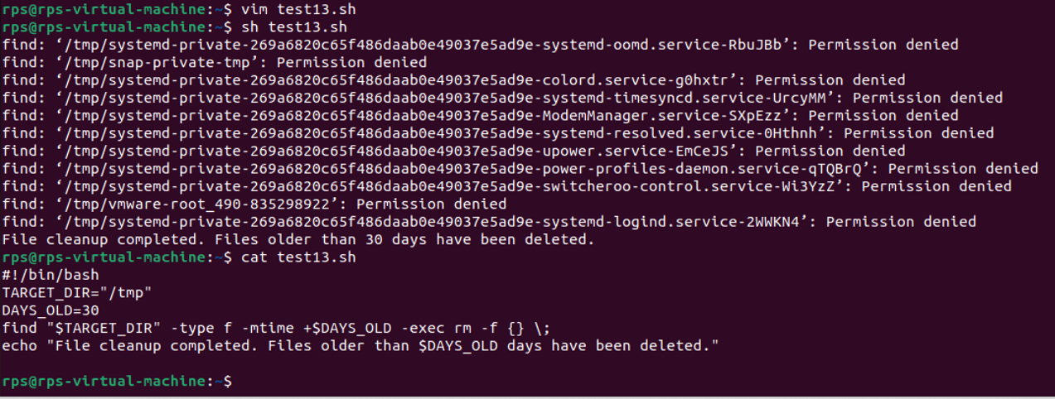

**Automated Updates:**

**Write a shell script to automatically update all installed packages on the system.**

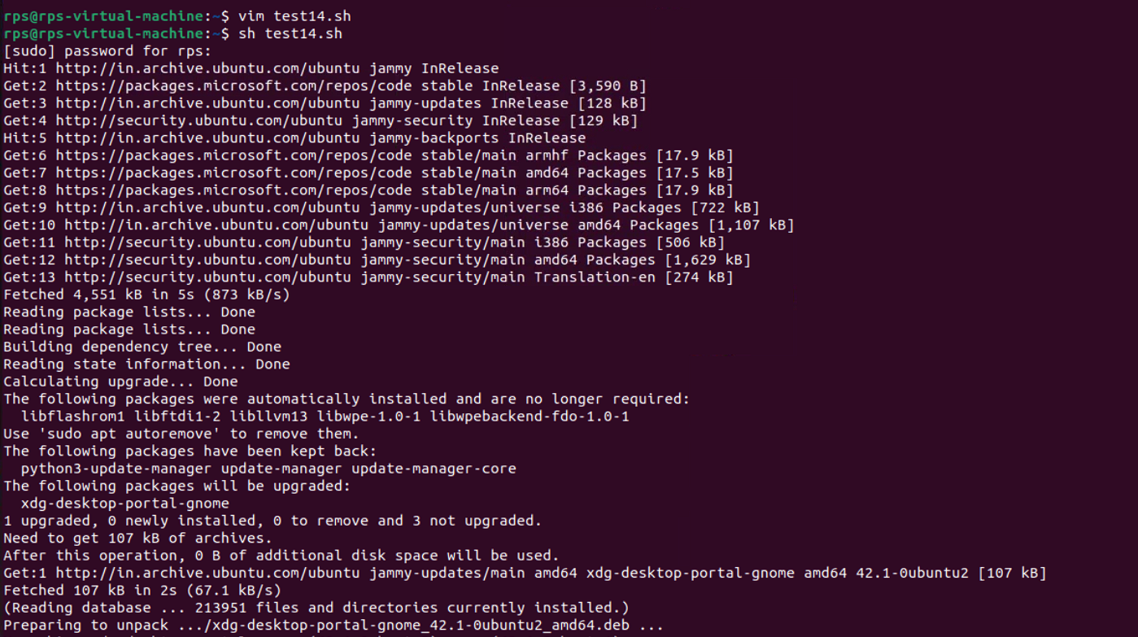

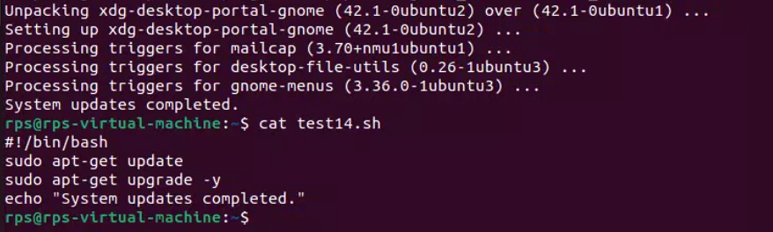

**Database Backup:**

**Write a shell script to back up a MySQL database named sales to a file named sales_backup.sql.**

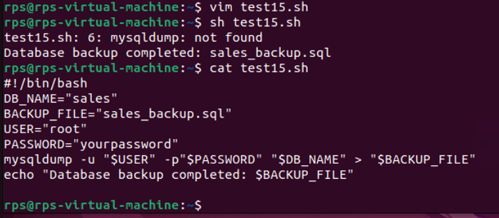**System Information:**

**Write a shell script to display system information, including hostname, OS version, and kernel version.**

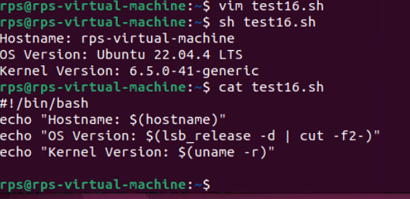

**Cron Job:**

**Write a shell script to schedule a cron job that runs a specific command every day at midnight.**

